Northern Virginia Independent Athletic Conference

is recognized as an
all league athlete
for outstanding achievements and contributions to the

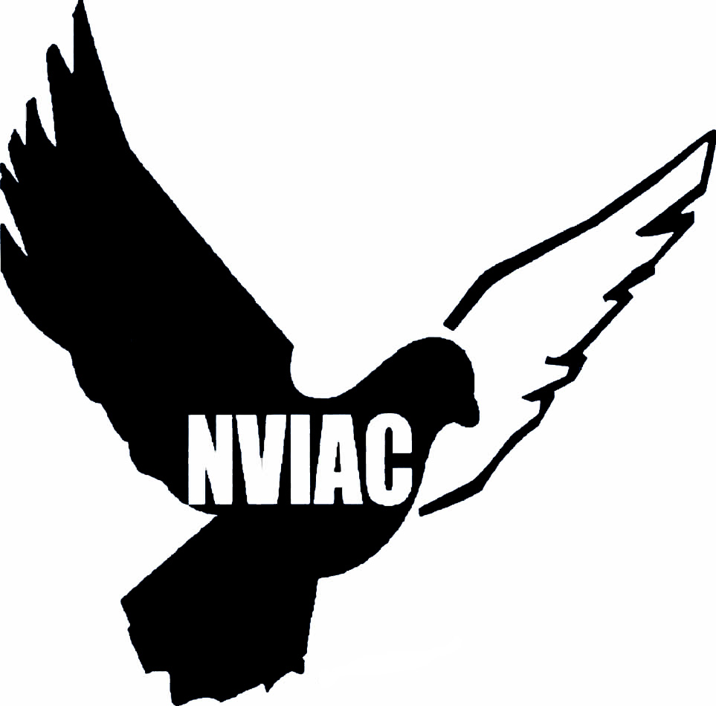

________________________
NVIAC President

________________________
Athletic Director

